Receptionist checklist
NHS England has published guidance to primary care prescribers to not routinely prescribe over the counter medicines for common conditions.
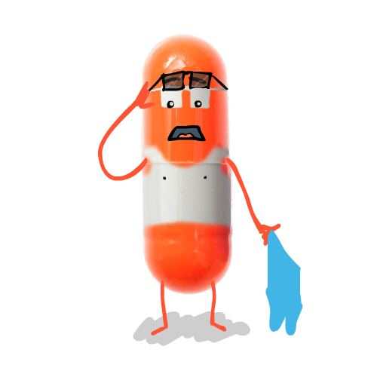
Please signpost patients to purchase over the counter medicines and seek help from their pharmacist for the conditions or treatments listed below.
Probiotics | Infrequent migraines
Vitamins and minerals | Insect bites and stings
Acute sore throat | Mild acne
Infrequent cold sores of the lip | Mild dry skin
Conjunctivitis | Sunburn
Coughs and colds and nasal congestion | Sun protection
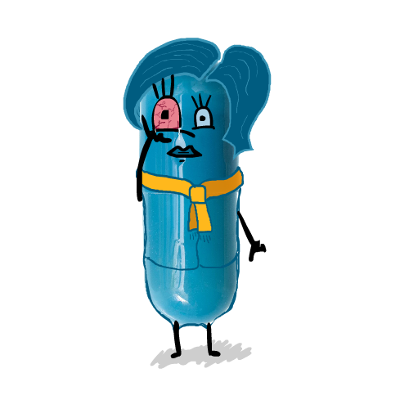  Cradle cap | Mild to moderate hay fever/Seasonal rhinitis
Haemorrhoids | Minor burns and scalds
Infant colic | 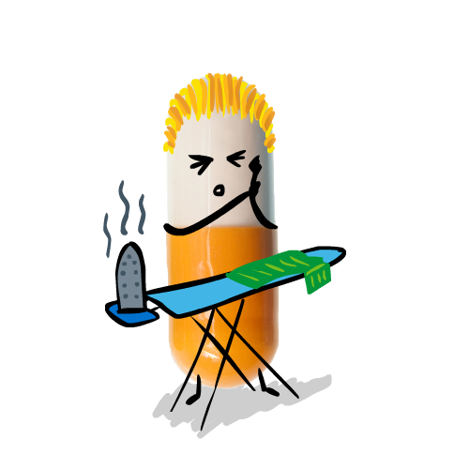  Minor conditions associated with pain, discomfort and fever (e.g. aches and sprains, headache, period pain, back pain)
Mild cystitis
Mild dermatitis | Mouth ulcers
Dandruff | Nappy rash
Diarrhoea (adults only) | Oral thrush
Dry eyes/sore (tired) eyes | Prevention of dental decay
Earwax | Ringworm/athletes foot
Excessive sweating (Hyperhidrosis) | Teething/mild toothache
Head lice | Threadworms
Indigestion and heartburn | Travel sickness
Infrequent constipation | Warts and verrucae
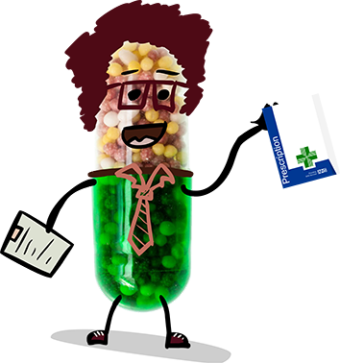
What are the benefits of using pharmacies?
- It prevents unnecessary GP appointments for common conditions.
- Access to pharmacies is easier and sometimes quicker than waiting for a GP appointment.
- Pharmacies are open out of hours, like late nights and at the weekend, which is convenient for people who work or when the GP practice is closed.
